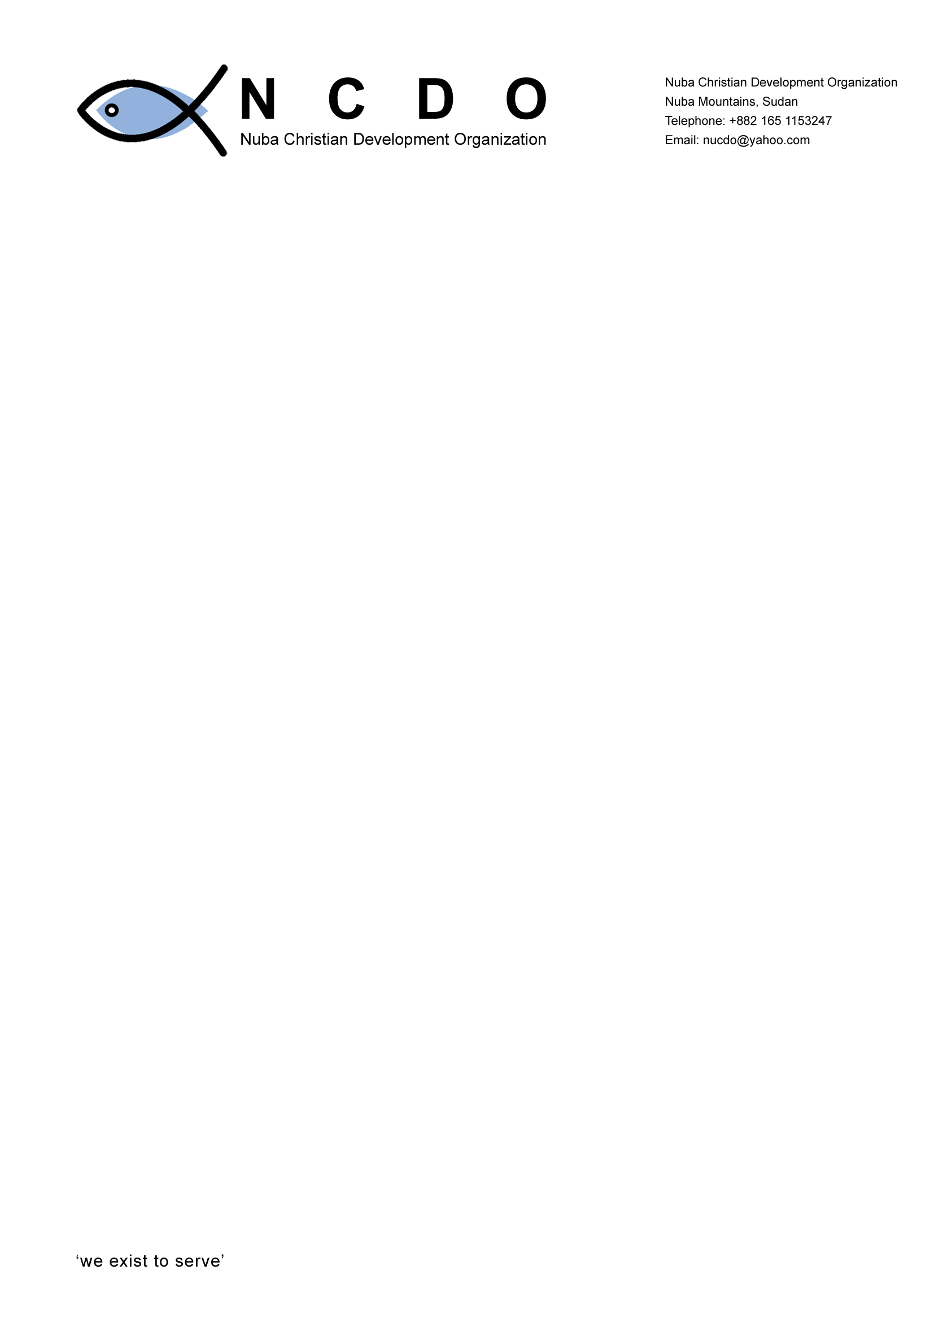

REPORT ON EXCHANGE OF EXPERIENCE
AND
BEST PRACTICES BETWEEN NCDO AND SASE IN SOMALILAND
IN THE FIELD OF SPECIAL NEEDS EDUCATION

AUGUST 2009

REPORT COMPILED BY;
JOSEPH MALISH FESTO
NCDO EXECUTIVE DIRECTOR
NUBA MOUNTAINS
Email: joseph.malish@ias.nu
Mobile: +249914301310

TABLE OF CONTENTS

ACRONYMS AND ABBREVIATIONS….............................................................3

ACKNOWLEDGEMENTS...................................................................................3

1.0 INTRODUCTION AND BACKGROUND OF THE VISIT................................4

1.1 Introduction...............................................................................................4

1.2 Objective ……………………………………………................................………………….4

2.0. ACTIVITY………………………………………………………………………………4

2.1. Day 1(Arrival and Visit to Hargeisa School…………………………………..4

2.2 Day 2(Visit to Barua Town and Sheik Ibrahim School………………………5

2.3 Day3 (Visit to Borama town)………………………………………………………6

3.0 DAY 4. (Exchange of experience and best practice)……………7

3.1. SASE: ……………………………………………………………………8

3.2 NCDO:…………………………………………………………………….8

3.3 The concept of SNE……………………………………………………………….8

4.0 Recommendations and way forward…………………………………..9

4.1 Recommendation; ………………………………………………………………….9

4.2 Way forward: ……………………………………………………………9

5. Out come of the Visit………………………………………………………………9

ACRONYMS AND ABBREVIATIONS

CPA Comprehensive Peace Agreement
IAS International Aid Services
KISE Kenya Institute of Special Education
MOE Ministry of Education
NGO Non-Governmental Organization
NCDO Nuba Christian Development Organisation
REO Regional Education Officer
SASE Somaliland Association for Special Needs
SNE Special Needs Education
SPLA Southern Sudan Peoples Liberation Army
SPLM Southern Sudan People’s Liberation Movement
PTA Parents Teachers Association

ACKNOWLEDGEMENTS
NCDO would like to thank the whole IAS family for their commitment in building its local capacity in this new field of SNE. Many thanks go to the IAS Director our dear “father” Leif for the full support in the arrangement of our flights. We also don’t forget Repent Taban and Abdarahim in helping us is securing our exit Visas in Khartoum.
We also extend our thanks to Ketema, Jama, and Joe for their tireless support for us while in Addis and Somaliland respectively. In addition, we thank Mr. Kuku (Stephen) for the idea he gave for NCDO members to go to Somaliland. We appreciate driver Mohammad for his good driving skills although some of us were closing the eyes while he was negotiating the Connors up on those huge mountains on the way to Borua. It was the first experience to travel on such roads
Lastly, we also want to extend our sincere thanks to IAS Denmark in particular, Maria and Torben for the full support they are offering to NCDO. We thank God for you all and who so ever played a great role in one way or the other although your name has not been mentioned. NCDO will succeed in the project and those that the project is intended to serve will surely receive the services.

1.0 INTRODUCTION AND BACKGROUND OF THE VISIT
1.1 Introduction:
The visit of NCDO members to Somaliland was to exchange experience and share best practices in the field of SNE with SASE. It is one of the prerequisite for NCDO to learn more through SASE issues pertaining SNE before implementing the program in south Kordofan state (Nuba Mountains) in particular.
The visit came because of the failure of SASE members who were to come to Nuba Mountains during the first SNE conference organized in May 2009.
However, NCDO executive members requested to go to Somaliland as the SASE members failed to come and IAS supported the idea.
1.2. Overall objective:
NCDO executive members visit to SASE, IAS Somaliland is to exchange experience, and best practices the field of SNE in order to implement and use the experience of SASE and IAS members in Nuba Mountains.

2.0. ACTIVITY
2.1. DAY1 (arrival and Visit to Hargeisa School for Special Needs
The team arrived Hargeisa at around 2:30pm on Tuesday 18th/ 8/2009 and was warmly welcomed by Mr. Joe From the airport and the rest of the IAS team members in the guesthouse,

At around 4:00pm, the team visited Hargeisa School for special needs that SASE is running and had some general briefing and history of the school by Mr. Jama the administrator of the school and Joe.
Findings;
SASE was established in 2005 and took over the role of IAS in running the project of SNE. But before the establishment of SASE, IAS first recruited teachers who were trained for special need program for about 3 months on certificate level, after that the community and government officials were made aware of what was taking place,
A general community sensitization was made using loud speakers calling for parents to send their children with special cases to the school,
The community’s first concept was not healthy, they thought the children were going to be given medication and physical help, but how ever, through continues training of the communities and government officials, the idea of the program was positively conceived by all stakeholders and became successful.
NCDO was informed that the whole process of community awareness and sensitization took over two months.

Establishing the program in Nuba Mountains.
SASE identified the following based in their experience.
- First and for most, SASE advised NCDO to do a lot of awareness, the government and community leaders should be sensitized of the importance of the school for such children.
- NCDO should seek the support approval of the government towards the program.
- The behavior of parents of children with special needs should first be changed in order to allow their children to school.
- NCDO should also train teachers with the heart for children with disabilities.

- NCDO should also consult and incorporate other interested agencies in the field of special needs for broader expansion of the program.
- Hospitals, churches and mosques should also be informed of the program to widen the identification of children with disabilities to be brought to the school.
SASE also did not neglect to inform NCDO about the challenges’ that they meet and how they overcome them.
One of the challenges they got was the nick naming of teachers as being teachers for the mad people.
More so, IAS vehicles were written on it when ever packed on the road side” vehicle for the mad”.
Other challenges include, high cost of running the program, children with special needs were not accepted and valued by normal children and long distances in bringing in all the children to school.

2.2. Day2 (Visit to Barua Town)
The team travelled for 4 hours to see some of the projects in Barua town and to meet the regional education officer (REO).
The REO (Mr.Abdi Ahhamed Said) gave the history of SNE in the in the town of Barua as started in 2006. an assessment centre has been established and some teachers were trained including him through the support of IAS. According to the REO, the government now has taken an upper hand in supporting the SNE program in the region. They have now established a separate office for Special needs within the ministry of education. More so, they are contributing in offering curriculum and teachers to be trained for the program.
Sheikh Ibrahim School.
The team including the REO visited the above inclusive school consisting of primary, secondary and special school for the dump and deaf children.
The school is having an assessment centre which serves as awareness centre for parents and a meeting place for the teachers and parents. According the teacher in charge of special needs, they have assessed over 280 children with different cases. Where those found with mild problems are sent to join regular schools although he some times monitors them on their performance, behavior change and progress in the classes. Those with critical cases were sent to hospitals for treatment while the ones with permanent cases example, the dump, deaf that cannot be treated are enrolled in a special school for special training.
The only problem the school is facing is that normal children in the schools disregard some times children with disabilities and more so, other teachers tend to be indifferent with children with special needs.
The school is doing well and NCDO members were very grateful to see the progress of the school and the children in the class learning with grate smiles on their faces.

The team meet with SASE members in Borua to find out how they succeeded and the challenges they are facing now on running the special need program.
SASE gave a brief background of the organization as established on 18th 2/2009 with seven board members. They organized workshops on management and leadership. Carried out awareness on SNE in rural areas and schools

Lesson learnt.
SASE and the REO of Barua advised NCDO members on the following:
- The concept of SNE is quite new to most communities there fore, the attitude of parents and close relatives of the affected child should first be changed and this needs special care and attention.
- NCDO should first do an awareness campaign to all communities, community leaders, government officials and the ministry of education officers. This will make it easier for the program to be understood during implementation.
- Awareness is important because, if communities are not formed of what SNE is, parents always think for medication first other than education of the affected children. Therefore, they needed to be properly sensitized to avoid miss conception of the project.
- School children and teachers on the other hand need to be informed and trained on issues of children with disability and the concept of ‘ education for all’ other wise, Normal children will not accept children with disabilities to sit near them and will intimidate the ones with special needs.
- NCDO should officially inform relevant local and civil authorities and other governmental bodies and seek for approval from them before carrying out any activity.
- School CECs (PTAs) should also be trained and sensitized on the issues of special needs to an able them to cater for the needs of such children in their schools.
- NCDO should also involve other actors on the field of Special needs to work in partnership with them and this will easy the implementation of the project.
- NCDO should also be in position to provide supplementing aid facilities such as visual aids, wheel chairs, hearing equipment and others to children who need them to boost their interest in coming to school.

2.3. Day3 (Visit to Borama town)
Nothing much was achieved by the ministry of education in terms of SNE program despite the presence of two trained teacher and an assessment centre built by IAS in one of the schools( Galbeedi Primary school). SASE is not yet present in the region and this probably contributed to ineffectiveness of the program.
Annalina School.
However, we visited a private school of Annalina School for the deaf and blind. An Italian missionary doctor established the school in 1997 by the names of Annalina Tonen who passed away last year in Somaliland according to external sources.
Farah Ahamed who now is the head master of the school gave us a full story of how the school started up to when it became strong and well established.
According to Farah, the school started under a tree with only five children. The society by then had no idea of the problems facing the deaf and the blind. It took them time to sensitize the community and convince them to allow their children to come to school. The workers rode on donkeys and camel backs to all the rural areas sensitizing the people and assessing the children with disabilities. After one year, the school started functioning well and was divided into three special classes (visual, deaf and other physical disabilities).
However, later, the school was integrated although during its first stage, some children were not happy for being mixed together with the blind and the deaf. This took less time and through counseling, the students now stay happily together and help one another.
The school now has vocational classes for carpentry, sowing and computer classes.
The school has a boarding section for students who come from far areas.
Children who graduated from Annalina School are enrolled in other secondary schools around and according to Farah; two of his teachers have been taken to one of the schools to teach all the subjects in the secondary school using sign language.
It is interesting to note that, even the parents for the deaf children are brought to the school to learn the basic structured sign language/communication in order to understand them selves at home
Those children in vocational school are provided with tools during graduation so that they can become self-reliance as they establish their own jobs.
Problems faced
- Annalina main challenge was getting land for the school. Since land in Somaliland belongs to the individual, this made it very difficult to get enough land for construction of the school.
- Other challenges like wrong attitude of the communities towards disabled children were also greatly encountered during the establishment of the school.
- Transport was another set back during mobilization and community awareness process.

Lesson learned:
  - NCDO to include training of parents of children with special needs in the program
  - Acquire land for schools construction and lob for funds from donors and other well-wishers for construction.
  - NCDO should encourage opening of inclusive schools for all children with disabilities other than special schools.

3.0 DAY 4. (Exchange of experience and best practice)

Mr. Joe Mwangi a specialist on SNE from KISE chaired the meeting between SASE and NCDO members.
It was one of the important meetings that both sides shared their experiences in different levels.
14 members altogether attended the meeting.

3.1. SASE:
Was created to help children with special needs in Somaliland. It acts as a voice for such children in advocating for their rights for education.
SASE was formed in 2005 and now works in partnership with IAS and Somaliland ministry of education .SASE board members come from the parents of children with special need cases.
It has now grown strong and gained support from the government (ministry of education) which allocates to SASE a budget for each year as government contribution to support the program.
SASE in collaboration with KISE developed a special need education curriculum and standard booklets for SNE in Somaliland and the ministry of education has adopted it. They now train SNE teachers, organize workshops and carry out sensitization through the support from IAS.

Challenges:
There have been too many changes on the board members that make it not stable in most cases in its leadership. So far, since 2005 SASE has changed some of its members three times.
The communities to some extend misunderstood the vision and objectives of SASE and this made SASE not to be effective in some places in pursuing its goals.
When IAS reduced its support to SASE, it became difficult to expand its activities to the intended places.
3.2 NCDO;
Was formed in 2005 but got full recognition in March 2008. NCDO does not have any experience in special needs education but has quite a good experience in pre-school and secondary school that it is running currently.
NCDO has 7 Board of governors members, 5 executive members and over 30 implementing staff in all its program sectors. It has multi sect oral programs such as water and sanitation, education and community training programs.
Challenges:
The main challenge in the education sector NCDO is facing is the lack of trained local English teachers. Since the cease-fire in 2002 between the government of Sudan and the SPLA forces, the Nuba people living in the SPLA/M administrative boundaries (mainly in the rural areas) changed their system of education from Arabic to English system. Where else, there are no qualified teachers with the exception of Arabic teachers. This made NCDO like any other NGO supporting the English schools to transport teachers from South Sudan, Kenya or Uganda and this is quite expensive and costly in terms of transport and maintaining the teachers.

3.3 The concept of SNE.
NCDO is now taking the new concept of SNE to be included in its education program and is very optimistic that the program will be of a great help to the vast number of children with special needs in South Kordofan and other parts of Sudan.
Many children with special needs are left out and are not given the rights to school due to cultural and traditional norms, but now NCDO is taking the challenge to make sure that the neglected children are attended to and have access to school like any other normal children.
The executive members now have known what it takes to implement the project based on the experience got from SASE members and the visit to the special schools in Hargaisa, Barua and Borama.

4.0 Recommendations and way forward
4.1 Recommendation;
Based on the experience of SASE, NCDO came up with the following recommendations
- In addition to the four NCDO teachers who are under going the training on SNE, NCDO executive members should also receive basic training on special needs Education.
- There is a need for a specialist to be around in the first year of the project implementation to guide the teachers in assessment and training of other teachers and even monitor the teachers during teaching process.
- More so, NCDO community workers should also receive basic training on children with special cases to help in identification of such children wherever they might go for their activities.
- In the long term, IAS and the donors should help NCDO to come up with a curriculum for special needs that will conform to the Sudanese education standards.

4.2 Way forward:
“How can SASE and NCDO have a close link in working together”?
- Both NCDO and SASE came up with the following;
- Regular visitation of each other before the project ends.
- Sharing information and new ideas and exchange of labor / expertise for some times in the process of curriculum development and trainings.
- Drawing of a MoU between the two NGOs if all the above are going to be effected.

5. Out come of the Visit.
It is worth still to express that the visit of NCDO members to Somaliland is of great significance. We have now captured a picture of what to do, what is supposed to be done and what it takes in terms of SNE. The team witnessed and confirmed the successes of SASE and IAS in running the SNE program and now without doubt I would like to say that, NCDO can now be able to implement the program through the application of the experience gotten in Somaliland. In addition, as time goes by, we will keep on gaining more experience in the field of SNE in the remaining conferences to come and the training of NCDO executive that is due to be done.

